LAB EXPERIMENT RECORD

Department | AI&DS
Course Code / Course Name | DSA0602 / Data Handling and Visualization
Experiment | Data Visualization using R
Name | M.Teja kumar
Register Number | 192424308
Date | 3 October 2026
Day | Saturday

SET 8: EMPLOYEE PERFORMANCE ANALYSIS

Aim
To analyse employee performance data using a line chart, bar chart, and data table in R, and to build an interactive dashboard in Tableau.

Dataset: Employee Performance

Employee ID | Department | Years of Service | Performance Score
1 | Sales | 5 | 85
2 | HR | 3 | 92
3 | Marketing | 7 | 78
Note: The dataset does not contain a date column, so Years of Service is used as the time axis for the performance trend in Program 1.

PROGRAM 1: Line Chart of Performance Trend
Create a line chart to visualize the performance trend of employees over time. Label the axes and title the chart.
# Dataset
employee <- data.frame( Employee_ID = c(1, 2, 3),
Department = c("Sales", "HR", "Marketing"), Years_of_Service = c(5, 3, 7),
Performance_Score = c(85, 92, 78))

# Arrange the employees by years of service (time axis) trend <- employee[order(employee$Years_of_Service), ]

# Line Chart
plot(trend$Years_of_Service, trend$Performance_Score, type = "o",
xlab = "Years of Service", ylab = "Performance Score",
main = "Performance Trend by Years of Service", col = "blue",
xaxt = "n",
ylim = c(70, 100))
axis(1, at = trend$Years_of_Service)
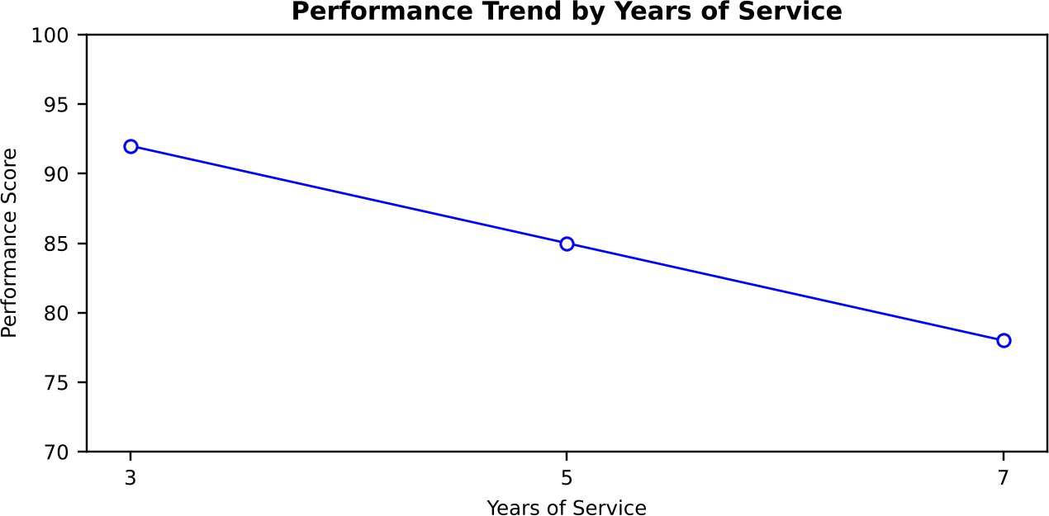

Output 1: Performance Trend Line Chart
Observation: The performance score falls from 92 at 3 years of service to 85 at 5 years and 78 at 7 years. The score drops by 7 points for every 2 additional years, giving a steady downward trend.

PROGRAM 2: Bar Chart of Performance by Department
Generate a bar chart showing the distribution of employees across different departments. Label the chart elements.
# Bar Chart barplot(employee$Performance_Score,
names.arg = employee$Department, xlab = "Department",
ylab = "Performance Score",
main = "Performance Score by Department", col = c("skyblue", "lightgreen", "orange"), ylim = c(0, 100))
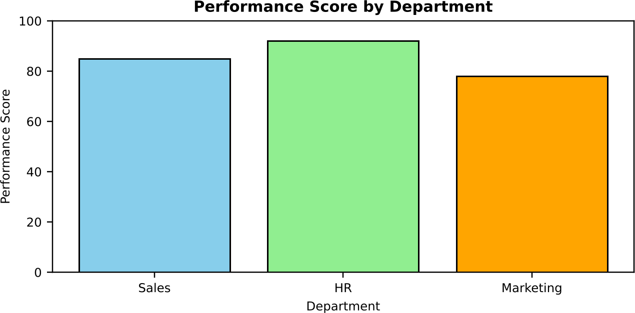

Output 2: Performance Score by Department (Bar Chart)
Observation: The HR employee has the highest performance score (92), followed by Sales (85). Marketing has the lowest score (78). Each department has exactly one employee in this dataset.

PROGRAM 3: Table of Performance Data
Build a table to show the performance data for each employee. Label the table elements.
# Add a rating based on the performance score
employee$Rating <- ifelse(employee$Performance_Score >= 90, "Excellent", ifelse(employee$Performance_Score >= 80, "Good", "Average"))

# Label the table elements
colnames(employee) <- c("Employee ID", "Department", "Years of Service",
"Performance Score", "Rating")

# Display the table print(employee)

Employee ID | Department | Years of Service | Performance Score | Rating
1 | Sales | 5 | 85 | Good
2 | HR | 3 | 92 | Excellent
3 | Marketing | 7 | 78 | Average

Output 3: Employee Performance Table
Observation: The table lists the department, years of service, and performance score of each employee with a rating (90 and above = Excellent, 80 to 89 = Good, below 80 = Average). The average performance score is 85.

PROGRAM 4: Tableau Dashboard for Employee Performance
Develop a Tableau dashboard combining the line chart, bar chart, and table for interactive exploration of employee performance data.

Steps in Tableau:
- Save the employee data as an Excel or CSV file with the columns Employee ID, Department, Years of Service, and Performance Score.
- Open Tableau, connect to the file, and load the data. Right-click Employee ID and choose Convert to Dimension.
- Sheet 1 (Line Chart): drag Years of Service to Columns (discrete) and Performance Score to Rows (SUM). Choose the Line mark type and title the sheet "Performance Trend".
- Sheet 2 (Bar Chart): drag Department to Columns and Performance Score to Rows (SUM). Choose the Bar mark type, drag Department to Color, and title the sheet "Performance by Department".
- Sheet 3 (Table): drag Employee ID and Department to Rows, then drag Measure Names to Columns and Measure Values (Years of Service, Performance Score) to Text. Title the sheet "Employee Details".
- Create a new Dashboard, drag all three sheets onto it, and arrange the two charts at the top and the table at the bottom.
- For interactivity, select "Use as Filter" on the charts and add a Department filter (Show Filter) so every view updates together.
- Title the dashboard "Employee Performance Dashboard" and save the workbook.
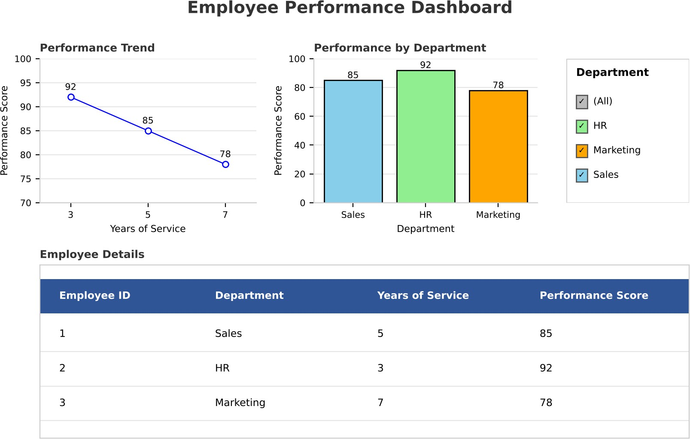

Output 4: Employee Performance Tableau Dashboard
Observation: The dashboard shows the performance trend, the department comparison, and the detailed table together. Selecting a department or a bar filters all three views, so users can explore employee performance interactively.

Set 8 Procedure
- Create a data frame with the employee ID, department, years of service, and performance score.
- Sort the data with order() and use plot() with type = "o" to draw the performance trend line chart.
- Use barplot() to display the performance score of each department.
- Add a rating with ifelse(), label the columns with colnames(), and display the table with print().
- Connect the dataset in Tableau, build the line chart, bar chart, and table sheets, and combine them in a dashboard with filters.

Set 8 Result
The employee performance data was successfully visualized using a line chart, bar chart, and data table in R. A Tableau dashboard combining all three views was created for interactive exploration.

Key Functions Used

Function / Tool | Purpose
order() | Sorts the employees by years of service.
plot() | Creates the line chart of the performance trend.
barplot() | Creates the bar chart of performance by department.
ifelse() | Assigns a performance rating to each score.
data.frame() / print() | Builds and displays the performance table.
Tableau Dashboard | Combines sheets with filters for interactive exploration.

